**Name : Affifa Amna**

**Sap id :55466**

**Course : computer organization and assembly language**

**Date of submission :16/10/2024**

Task :1

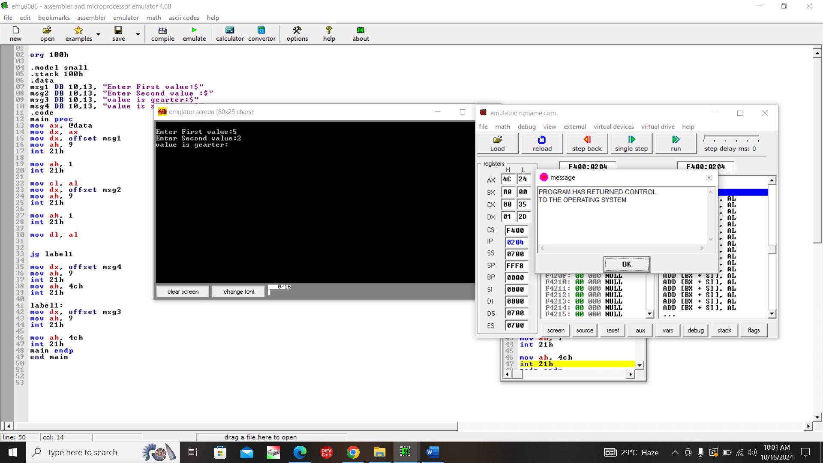

Task :2

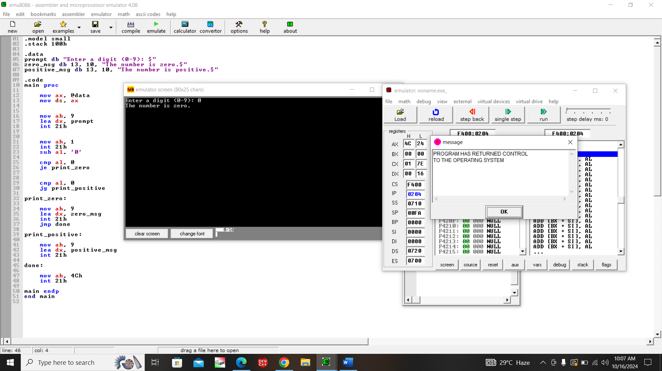

Task :3

